Use Cases - Detailed Documentation

**Login**

*JSP Files*

* Home
* AccountHome

*Accessible By:*

* Student, Faculty, Alumni, Admin

*Traceability Diagram*

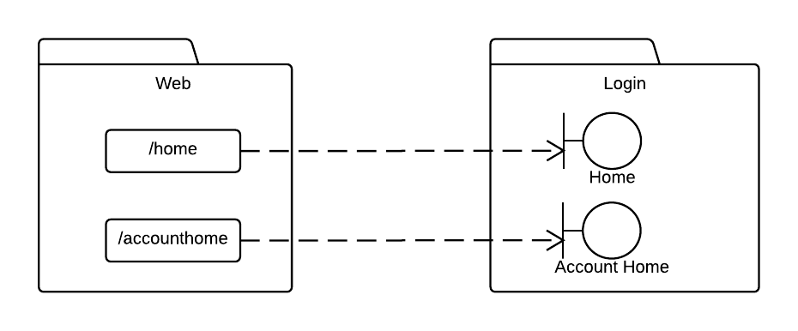

*Sequence Diagram*

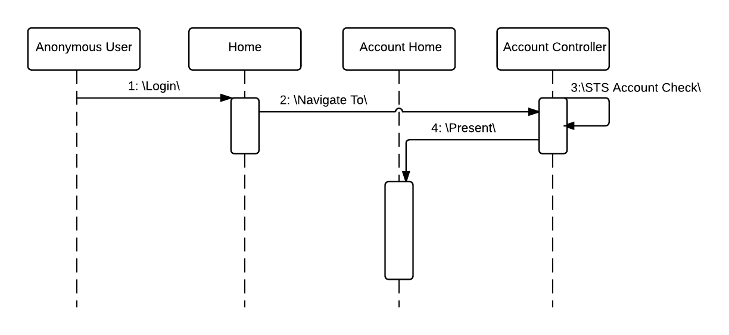

**Create Account**

*JSP Files*

* Home
* AccountRegistration
* AccountConfirmation

*Accessible By:*

* Student, Faculty, Alumni

*Traceability Diagram*

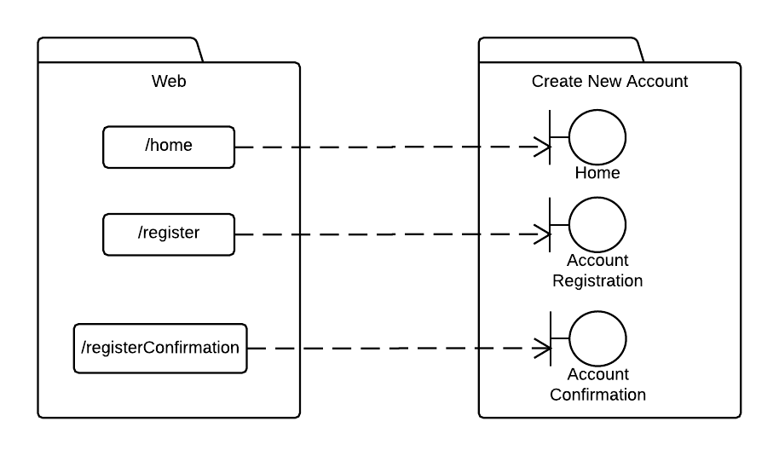

*Sequence Diagram*

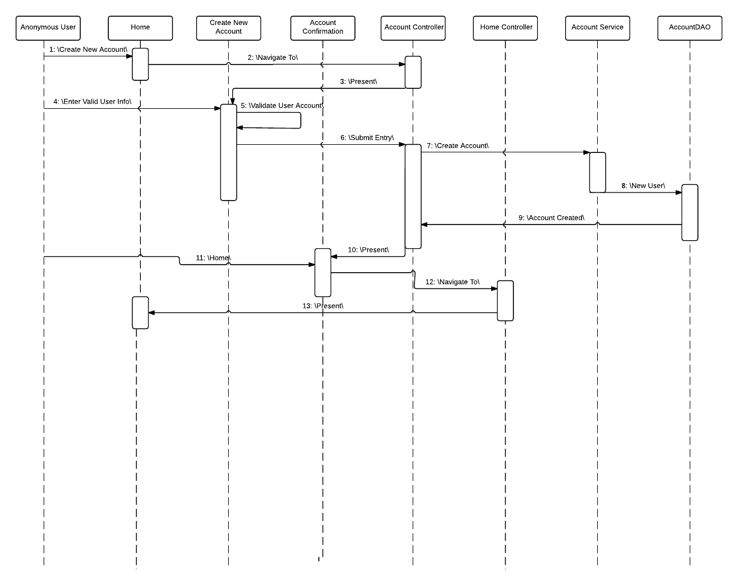

**Edit Profile**

*JSP Files*

* AccountHome
* EditProfilePasswordCheck
* EditProfile
* EditProfileConfirmation

*Accessible By:*

* Student, Faculty, Alumni, Admin

*Traceability Diagram*

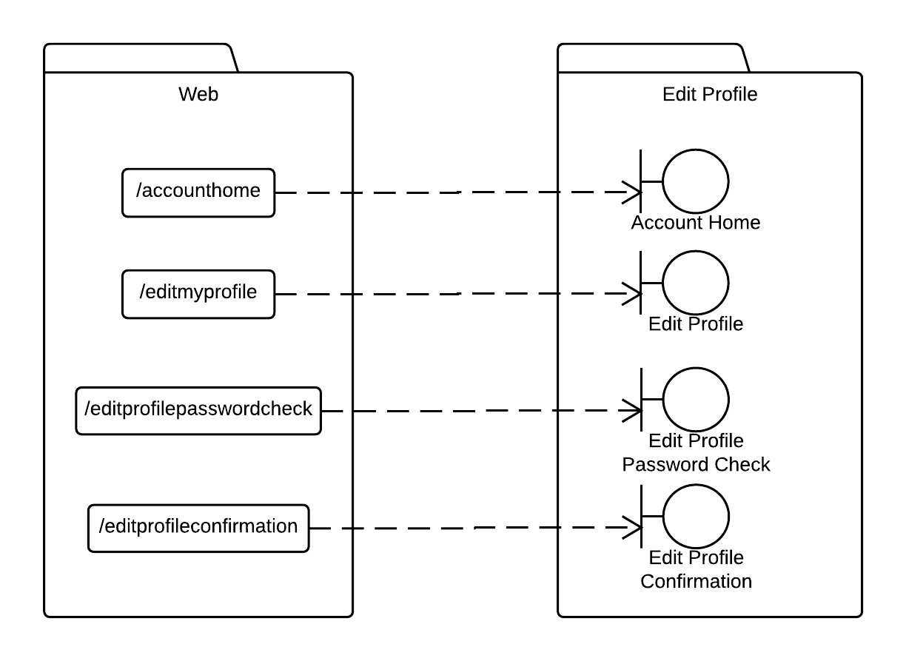

*Sequence Diagram*

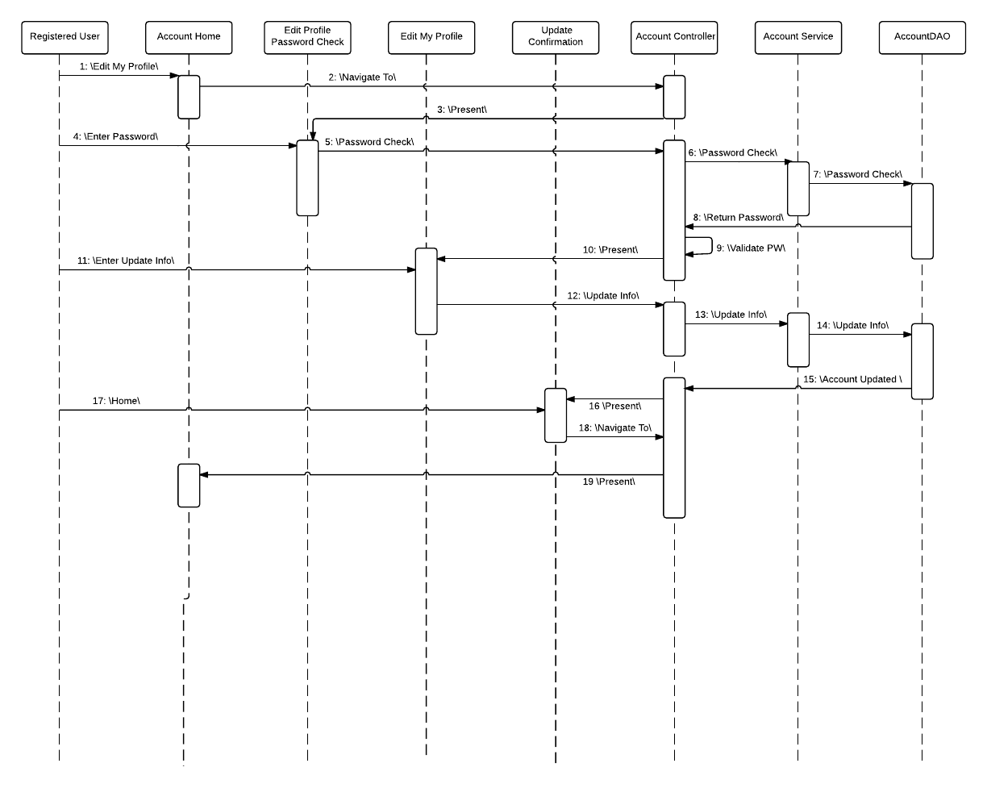

**Update Account Status**

*JSP Files*

* AccountHome
* AccountStatus
* AccountStatusConfirmation

*Accessible By:*

* Admin

*Traceability Diagram*

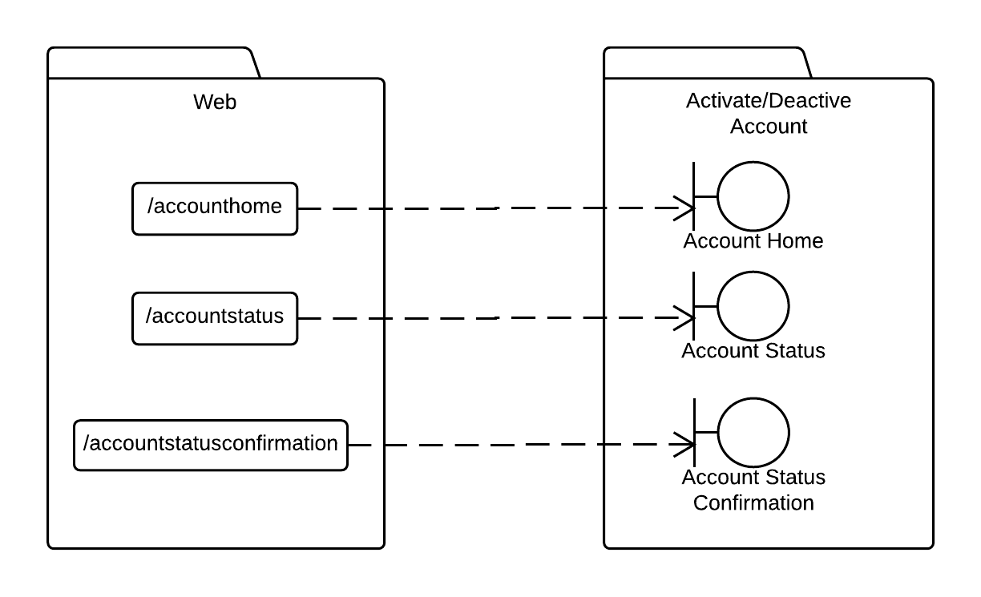

*Sequence Diagram*

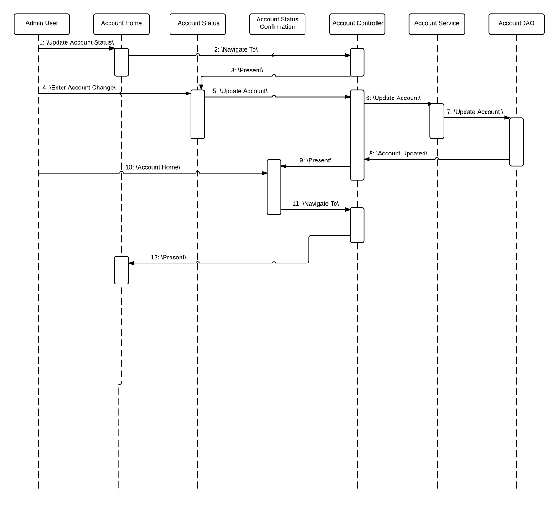

**Update Account Roles**

*JSP Files*

* AccountHome
* AccountRoles
* AccountRoleConfirmation

*Accessible By:*

* Admin

*Traceability Diagram*

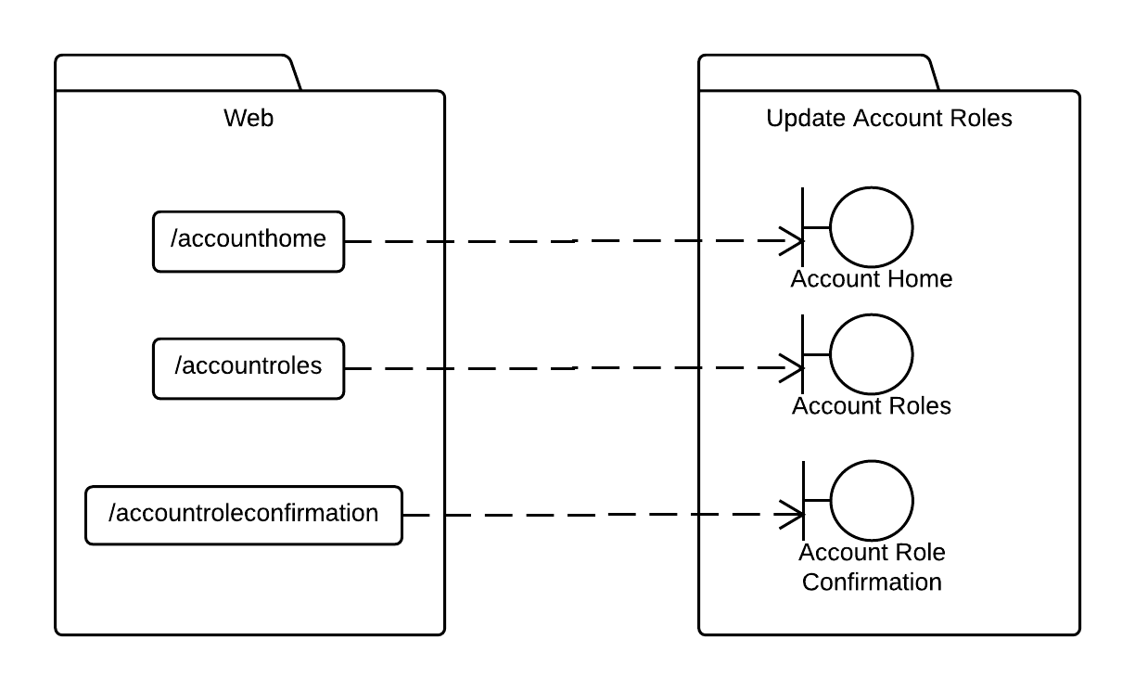

*Sequence Diagram*

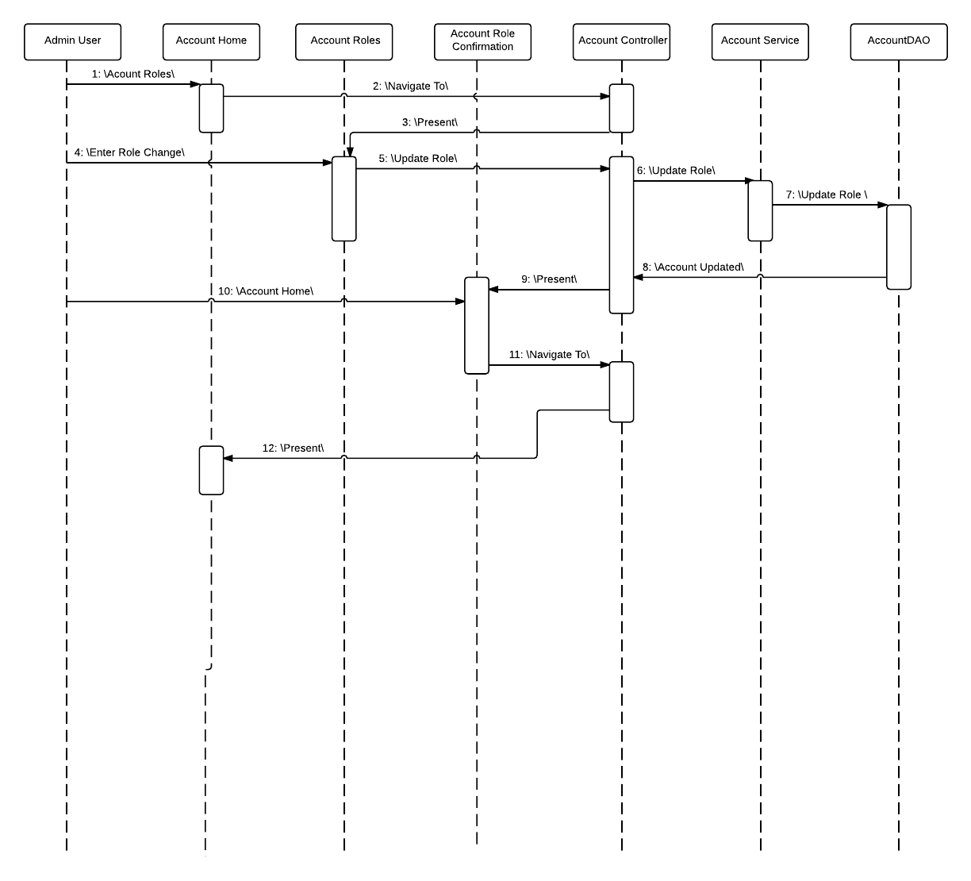

**Logout**

*JSP Files*

* AccountHome
* Home

*Accessible By:*

* Student, Faculty, Alumni, Admin

*Traceability Diagram*

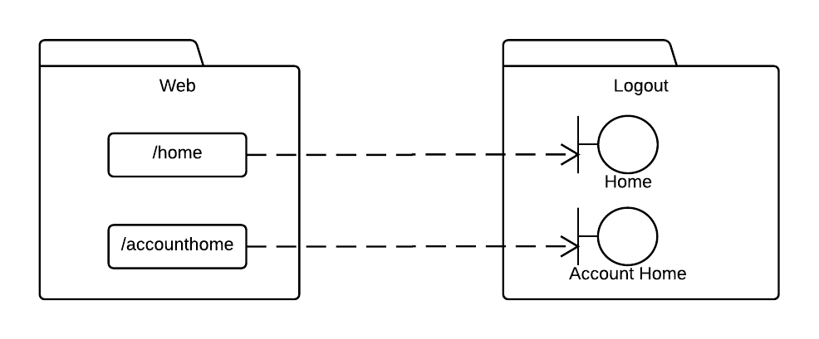

*Sequence Diagram*

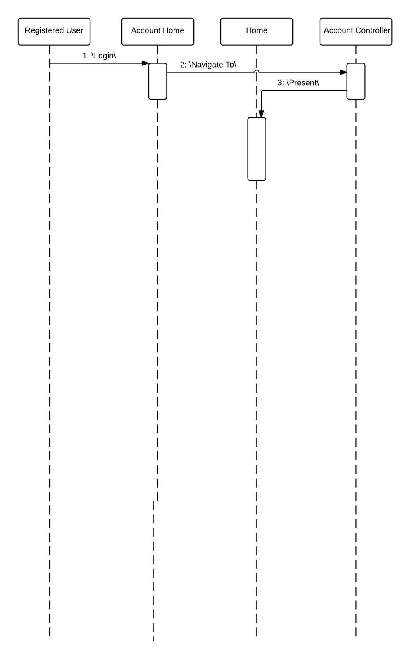

**View All Profiles**

*JSP Files*

* AccountHome
* ViewAllProfiles

*Accessible By:*

* Student, Faculty, Alumni, Admin

*Traceability Diagram*

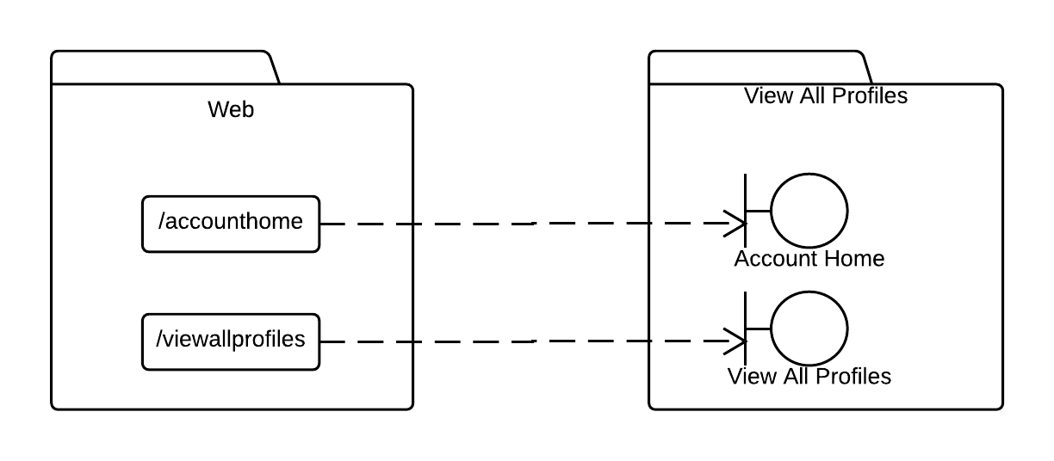

*Sequence Diagram*

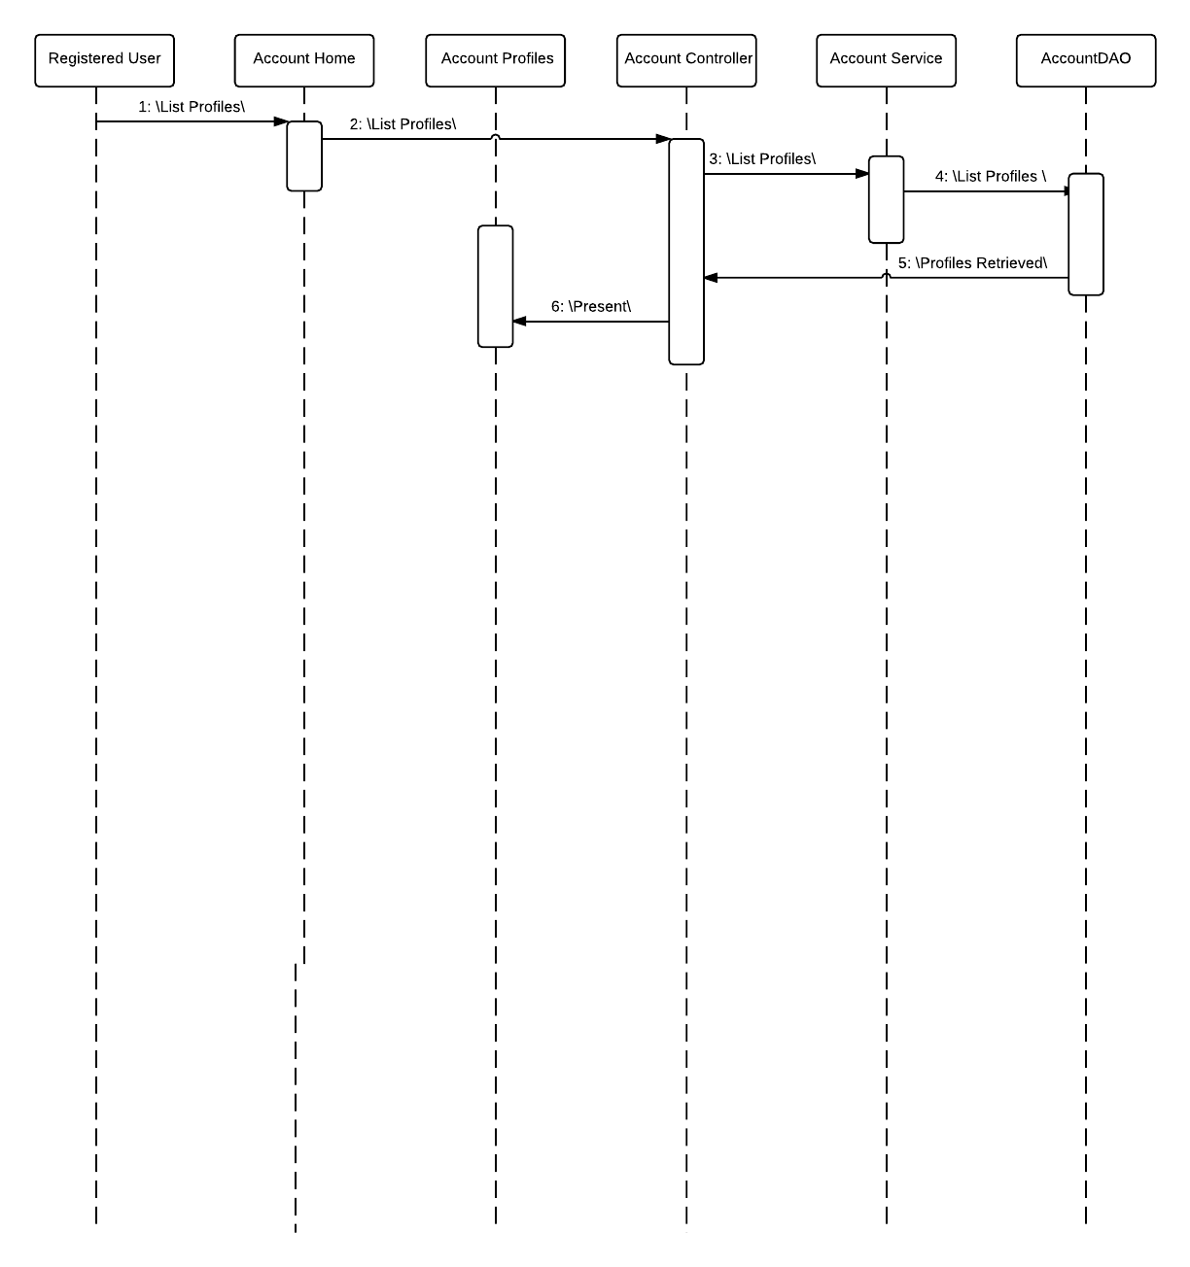

**Create Job Listing**

*JSP Files*

* AccountHome
* JobListingCreation
* JobListingConfirmUpdate

*Accessible By:*

* Faculty, Alumni, Admin

*Traceability Diagram*

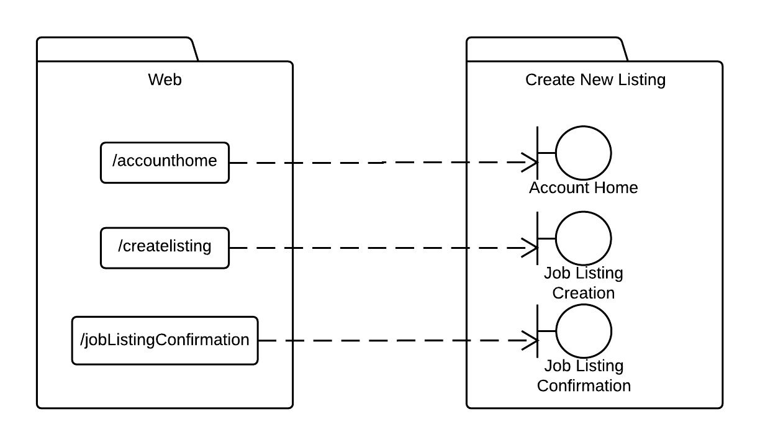

*Sequence Diagram*

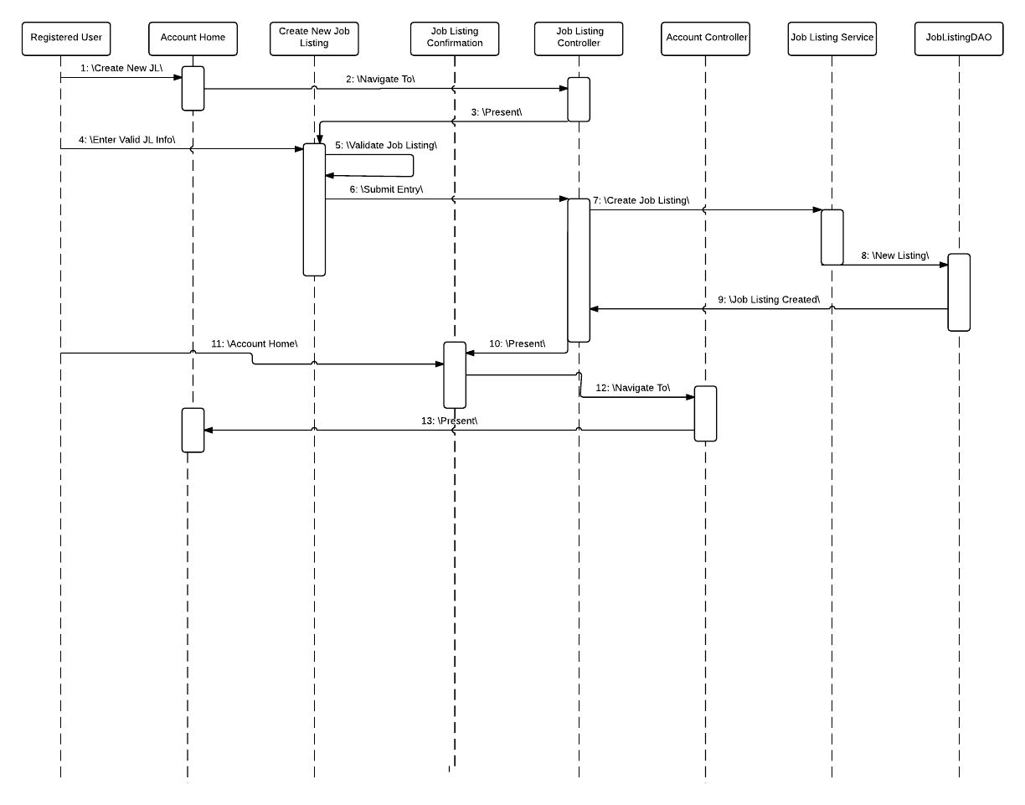

**Update Job Listing**

*JSP Files*

* AccountHome
* JobListingUpdate
* JobListingConfirmUpdate

*Accessible By:*

* Faculty, Alumni, Admin

*Traceability Diagram*

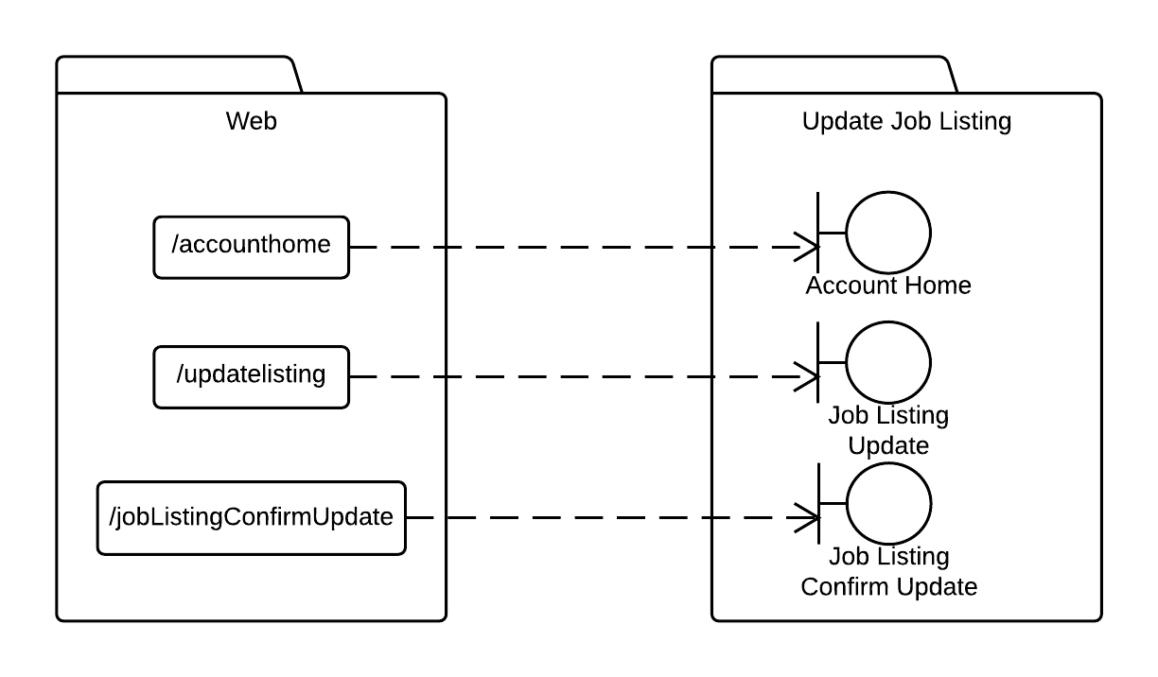

*Sequence Diagram*

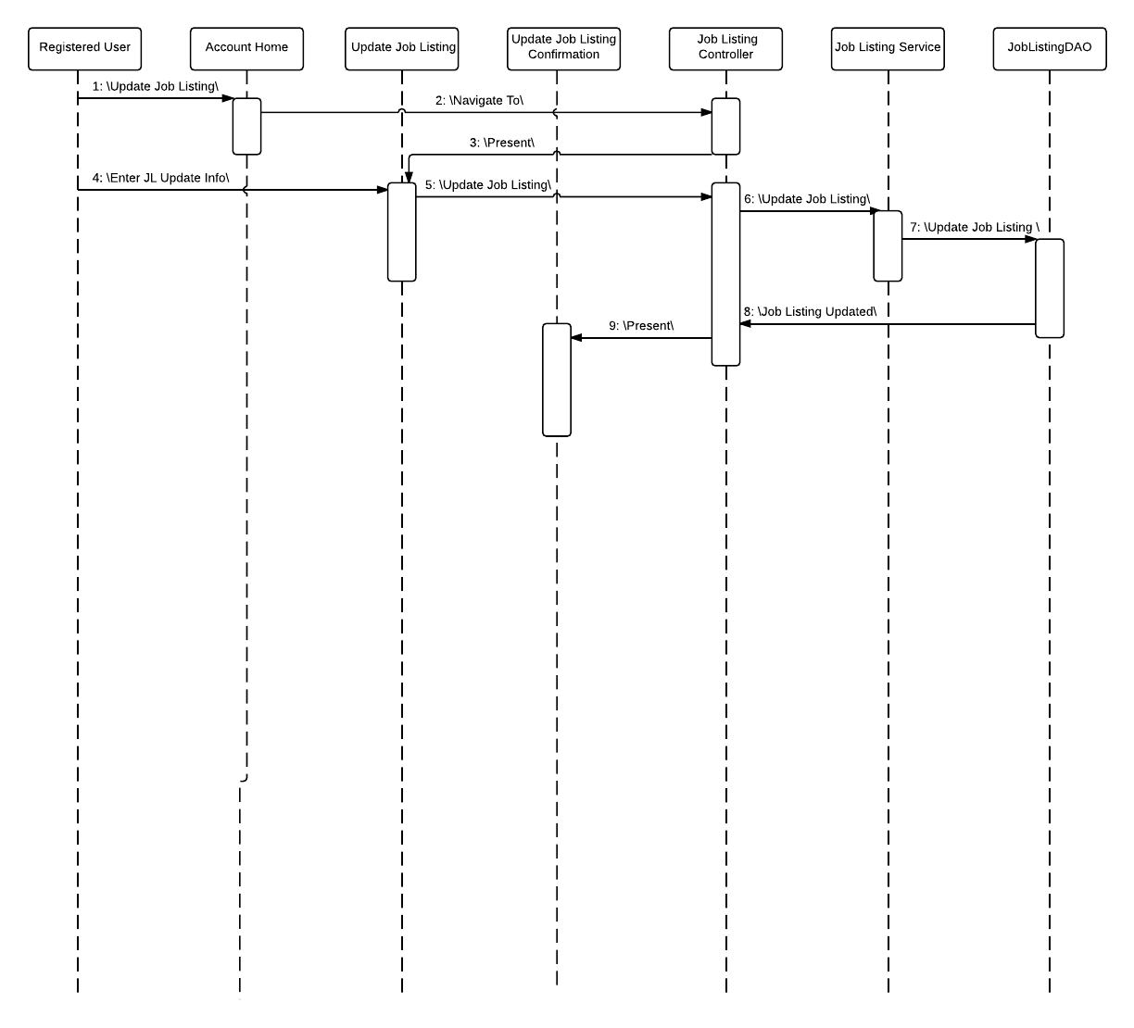

**Search Job Listings**

*JSP Files*

* AccountHome
* SearchListing
* JobListingFail

*Accessible By:*

* Student, Faculty, Alumni, Admin

*Traceability Diagram*

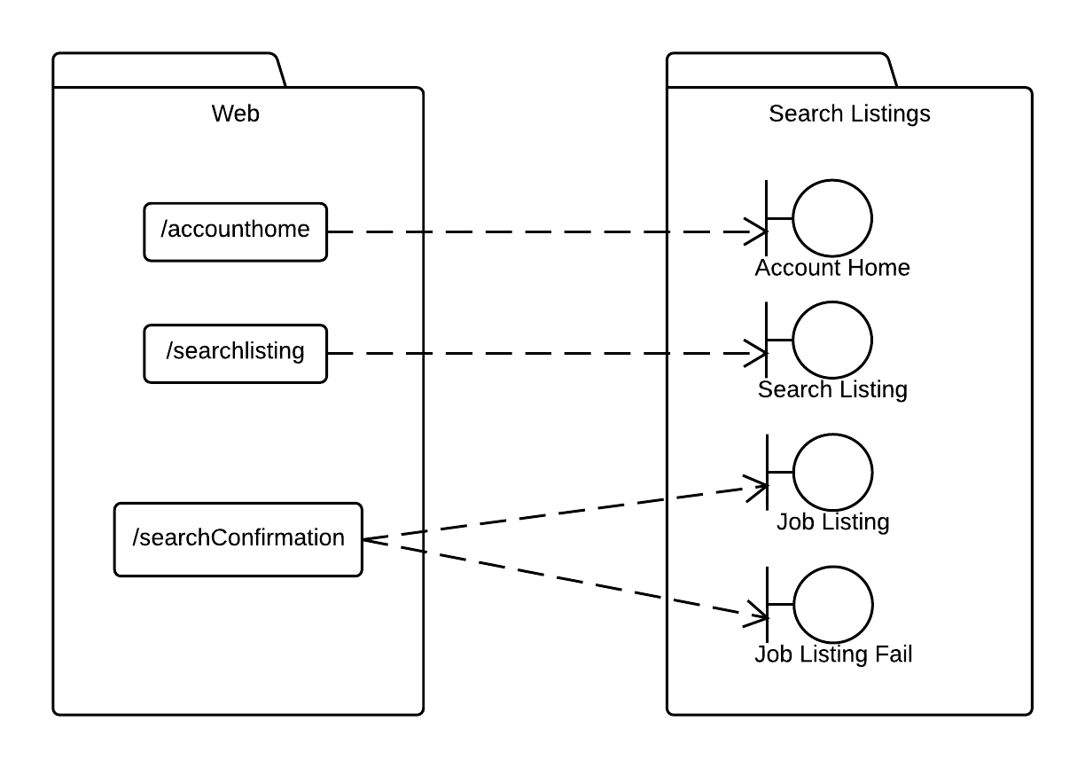

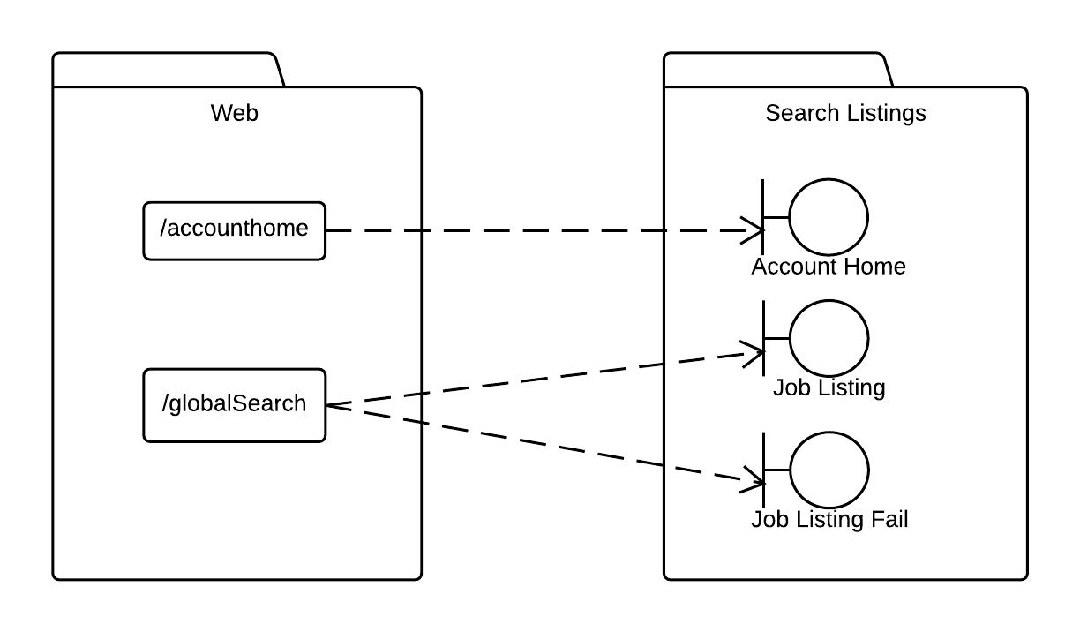

*Sequence Diagram*

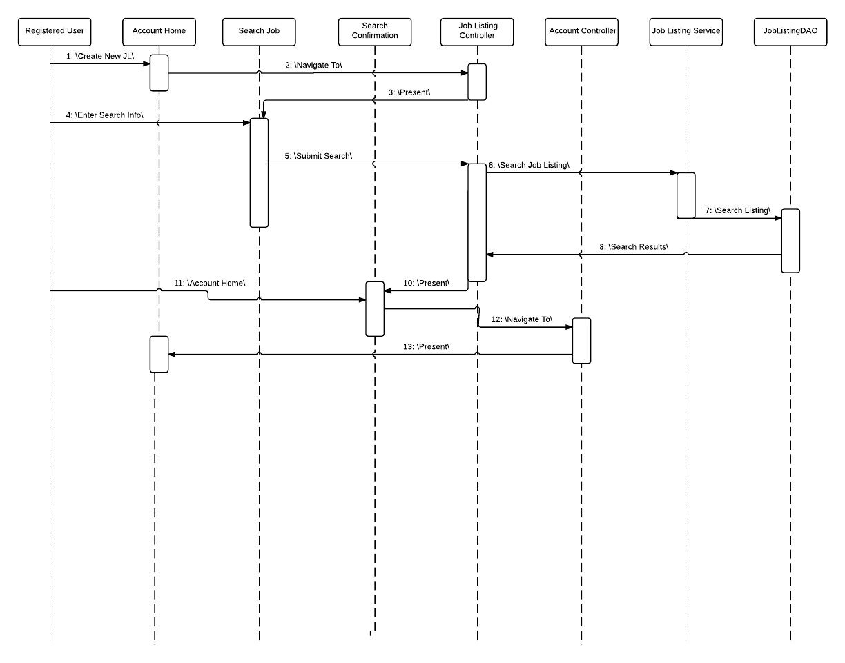

**Activate Job Listing**

*JSP Files*

* AccountHome
* JobListingStatus
* JobListingStatusConfirm

*Accessible By:*

* Admin

*Traceability Diagram*

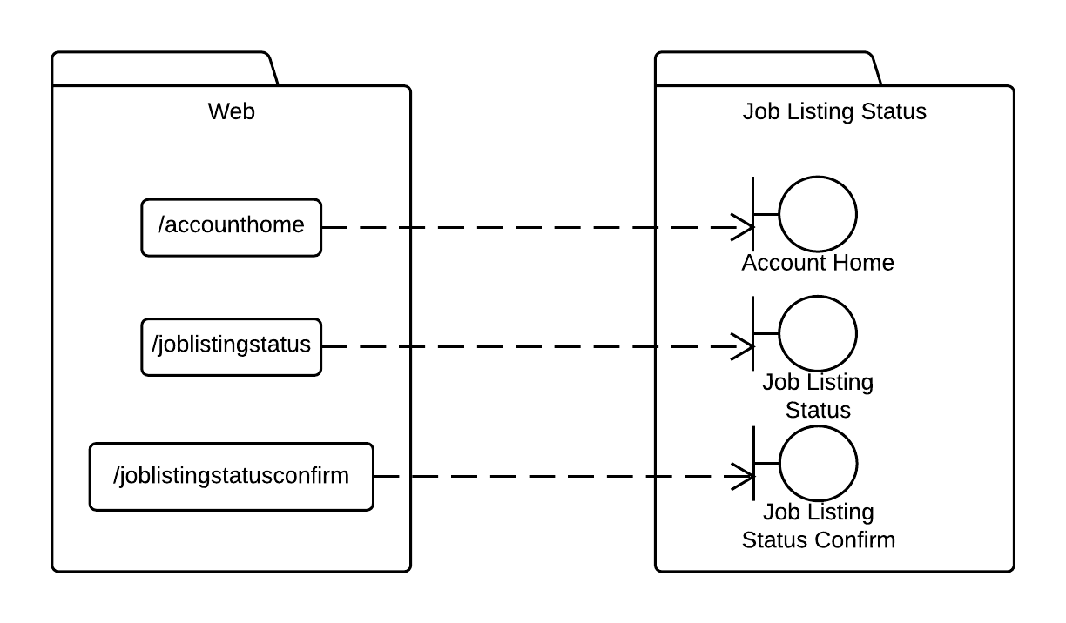

*Sequence Diagram*



**Deactivate Job Listing**

*JSP Files*

* AccountHome
* JobListingStatus
* JobListingStatusConfirm

*Accessible By:*

* Admin

*Traceability Diagram*



*Sequence Diagram*

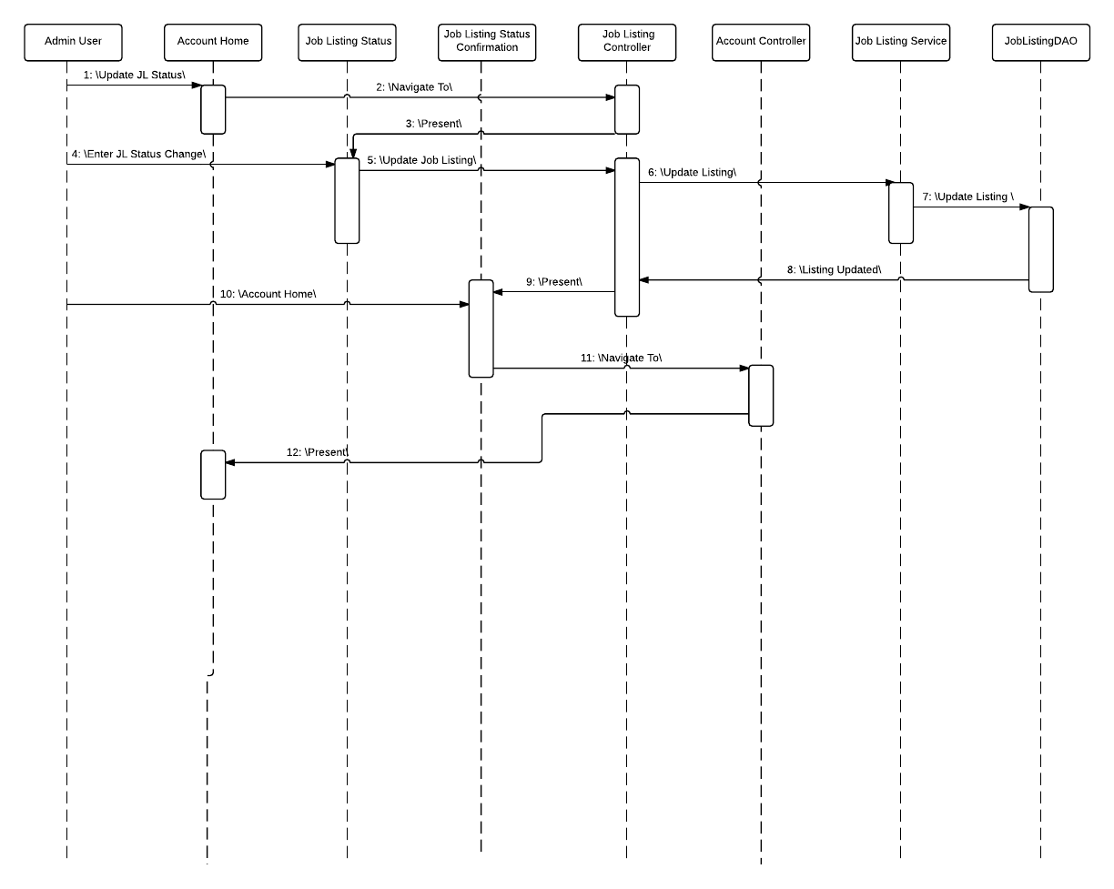

**View Job Listings**

*JSP Files*

* AccountHome
* JobListing

*Accessible By:*

* Student, Faculty, Alumni, Admin

*Traceability Diagram*

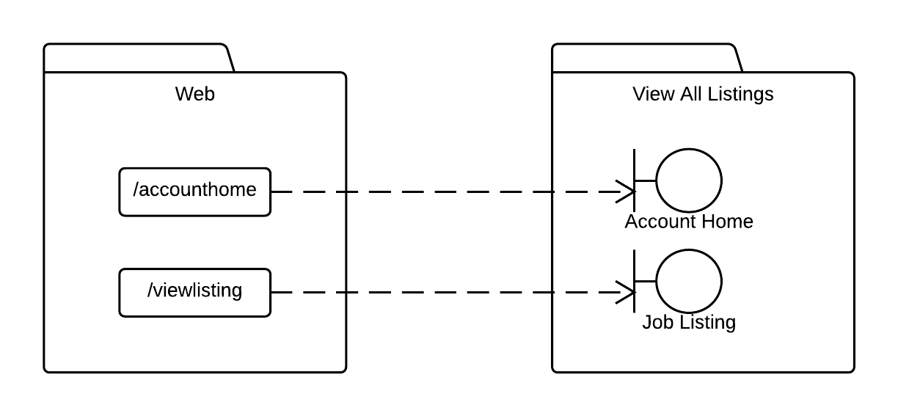

*Sequence Diagram*

